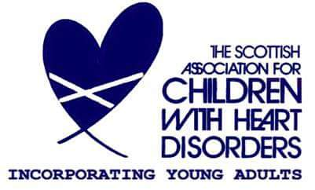

You are invited to the SACHD Glasgow Branch
Easter Event
featuring Ipdip theatre’s Head in the Clouds interactive theatre

Where: Children’s Hospital - 3rd floor rooms 27 and 31
When: Sunday 9th April
Time: 2pm-4pm
RSVP: glasgow@youngheart.info
Another great opportunity to catch up with friends and meet new families. We are excited to announce that this year we are hosting a very special all-ages theatre show from Ipdip theatre. A real treat for both our young and old heart children and siblings! This performance is funded by Awards for All Scotland. We will also have craft activities for you to enjoy with your children. Let us know if you can make it. If you are an inpatient then just turn up if and when you can.
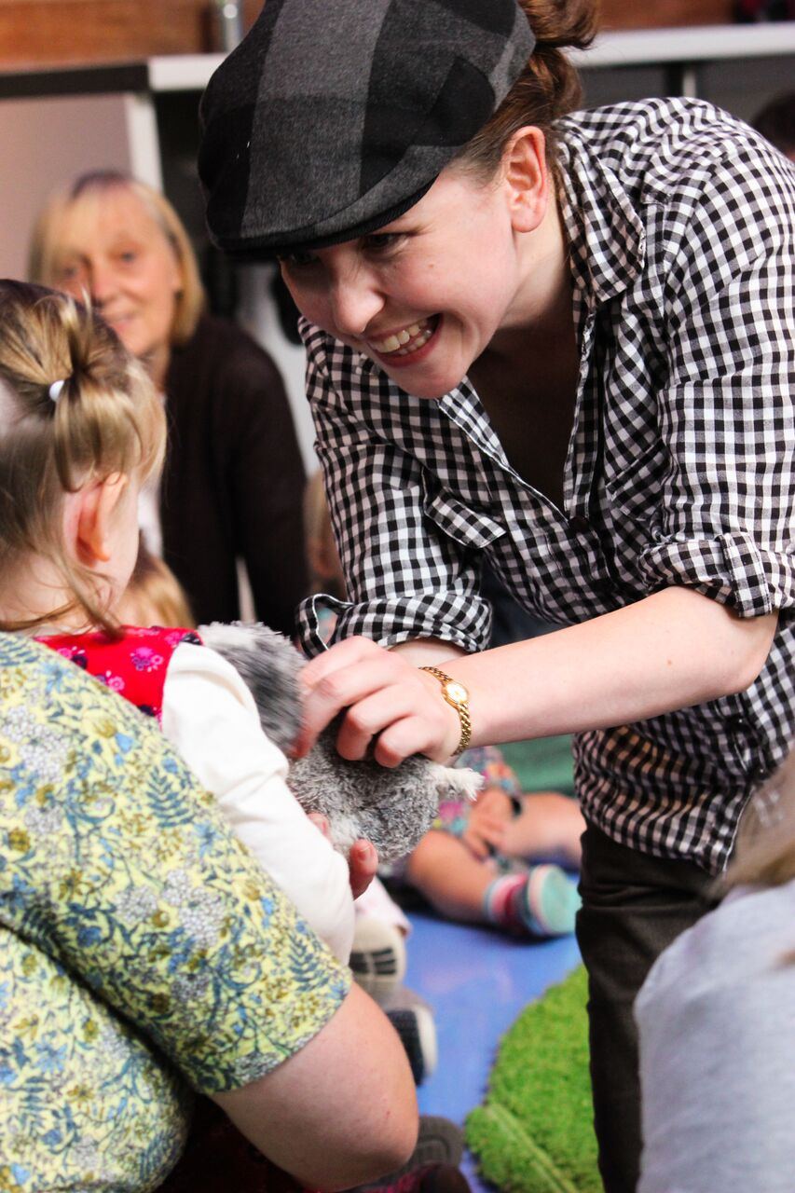
The sheep look down, the sheep look round, one sheep looks up and sees the clouds. When her mind wanders up and her feet follow after Cirrus the dog is left wondering how to bring these woolly-headed dreamers back down to earth. Ipdip Theatre bring a delightful, multi-sensory performance where rhythmic storytelling is interwoven with sound, touch and visual treats. A 2016 Edinburgh Fringe sell-out show made especially for children and families to enjoy together. Come and play!



